**YouTube tutorial 67 – Reading Custom File Structures**

https://www.youtube.com/watch?v=EjJY7yA5SWw&list=PLAE85DE8440AA6B83&index=67

#include "stdafx.h"

#include <iostream>

#include <fstream>

#include <string>

using namespace std;

int main()

{

ifstream inFile("watsup.txt");

int id;

string name;

int age;

while (inFile >> id >> name >> age) {

cout << "ID: " << id << ", " << "name: " << name << ", " << "age: " << age << endl;

}

}

**Result:**

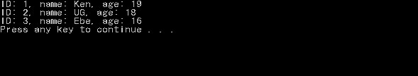

**File being read(watsup.txt):**

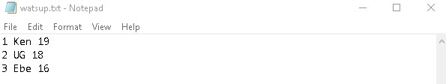

**Important notes:**